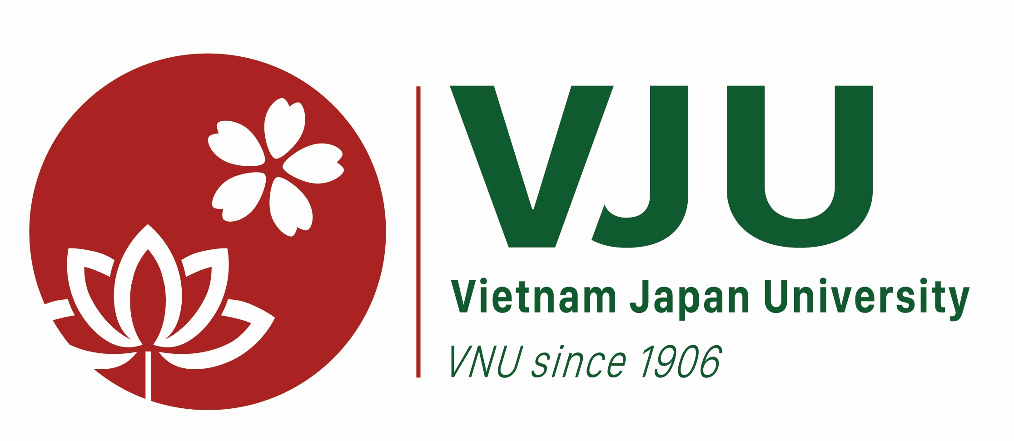
Workshop: “Career Guidance - Self Analysis & Self Promotion”
Focusing on working for Japanese companies in Japan
---
Date and Time: 15:30- 18:00, May 25th, 2017
Venue: R.415, 4th Floor, Vietnam Japan University, My Dinh Campus, Luu Huu Phuoc Road, My Dinh 1, Nam Tu Liem District, Hanoi
Language: English and Vietnamese
AGENDA

Time | Activities
15:30 – 15:40 | An overview of Japan’s labor market, labor demanding of Japanese companies (in Japan)
15:40 – 16:30 | How to express yourself with Japanese employers in Japanese way  - Personality promoting  - Self-analysis
16:30 – 17:20 | Interview skills and Practicing
17:20 – 17: 35 | Example of finding and apply for a job in Japanese companies (in Japan)
17:35 – 18:00 | Q&A

Link for registration: https://docs.google.com/forms/d/e/1FAIpQLScZBFCYvU_e-A7vUVWdPAb_Pum9BZLrNggoWD0PbiZKx1TMpw/viewform
CONTACT INFORMATION
Vietnam Japan University, VNU
Nguyen Thi Thu Dung (Ms), Academic officer
Tel: +84 4 7306 6001 ext 5093; Mobile: 0984853214
Email: ntt.dung@vju.ac.vn

